

FPT ACADEMY INTERNATIONAL
FPT – APTECH COMPUTER EDUCATION

AmazingBridges.com

Team: Group 1

Nguyen Huu Minh (Team Leader) Student1021979
To Nguyen Thien Chi Student1040277
Doan Khanh Nhi Student1038300
Tran Quang Ngoc Student1035445

Instructor:

Le Mong Thuy

September - 2017

This is to certify that
Mr./Ms.:
Nguyen Huu Minh
To Nguyen Thien Chi
Doan Khanh Nhi
Tran Quang Ngoc
has successfully designed & developed
eProject: AmazingBridges.com Website
Submitted by:
Nguyen Huu Minh
Date of issue:
16-Oct-2017
Authorised Signature:

Acknowledgement
This project consumed huge amount of work and dedication. Still, implementation would not have been possible if we did not have a support of many individuals. Therefore we would like to extend our sincere gratitude to all of them.
First of all we are thankful to Ms Le Mong Thuy for providing necessary guidance concerning projects implementation as well as her provision of expertise. Without her superior knowledge and experience, the Project could not have been successful. We also would like to express our sincere thanks towards the members of the team who devoted their time and knowledge in the implementation of this project.
Finally, we express our gratitude toward our families and colleagues for their kind co-operation and encouragement which help us in completion of this project.

Synopsis

Amazing Bridges is a website which provides information about various famous bridges around the world.
Amazing Bridges offers users the opportunity to learn more about World Bridges. All of the information is well organized and put into categories so it is very easy to search for and not time-consuming.
Amazing Bridges also allows its users to share their ideas with other people who have the same interest or even with the admin. Moreover, usefull information about buses and fights to reach the places is provided as well.

PROBLEM STATEMENT
Having read the project specifications, our team members realize that there are problems and difficulties which may interfere the users’ experience. In order to make the most precise decision and look for the best solution to tackle this, each developer has to consider the following querries thoroughly:
- How many categories are enough?
- How many bridges should be display on a page when they are grouped into categories?
- What information should be displayed on the homepage?
- How can the users interact with the website?
- How should the information about the bridges be shown on the page?
The website is to be developed for the Windows Platform using HTML5, JavaScript and Geolocation. The site should work well in all leading browsers including Chrome, IE, Firefox etc.

CUSTOMER'S REQUIREMENTS SPECIFICATIONS

Client: FPT_Aptech

Business / Project objective:
Provide users interesting information about famous bridges around the world.
Enable users to search for their favorite one through its name, all of the material can be downloaded from the website.
Help users to identify bridges location and find ways to reach there.
Input to the system:

From Webmaster:
- Details of some famous bridges.(features, history...including image)
- Location of the the bridges, buses and flights to to get to each monument
- contacts, mail

From website visitors:
- Choice of the classified categories or request for a specific bridge information
- Enter the names of the bridges which users would like to search
- Users’ feedback
Output from the system:
- Detailed information about the bridges as well as illustrated pictures
- Search results.
- Display location of the bridges and provide information about buses and flight to reach the places
- Output .pdf or .doc files for users to download
Hardware/ Software Requirements
Hardware
- A minimum computer system that will help you access all the tools in the courses is a Pentium 166 or better
- 64 Megabytes of RAM or better
Software
- Notepad/HTML editor
- Dreamweaver
- IE 5.0/ Netscape 6.0

Scope of the work (in brief):
After having a thorough discussion among members of the team, decision has been made to point out crutial requirements which need to be developed:
- All bridges are grouped into 4 categories
- Each webpage will display 5 bridges at a time
- Homepages will show menu options for category, about us, contact us and information about the most famous bridges
- User can give feedback and download file from the website
- Main features and histoy of the bridges will be presented on the webpage with pictures
Architecture and design of the system:
HTML, CSS, Javascript, Jquery, Bootstrap, Angularjs
Windows platform device

Clients

Server

Diagram of the website:

Begin

Top Longest

Top Highest

Top Oldest

Vietnam Famous
About us

FAQ

Contact

Advertisement

End

TASK SHEET REVIEW 1
No. | Description | Begin Date | TeamMate Name | Notes
1 | Problem Statement | 9/16/2017 | Minh
2 | Requirement Specification of AmazingBridges.com | 9/16/2017 | Minh
3 | Architecture and design of the system | 9/16/2017 | Chi
4 | Diagram of the website | 9/16/2017 | Nhi
5 | Description | 9/16/2017 | Ngoc
6 | Task Sheet | 9/16/2017 | Minh

Date:
Signature of Instructor:  Le Mong Thuy | Signature of Team Leader:  Nguyen Huu Minh

Site map:
Top Longest
Top Highest
World Famous
Top Oldest
Top Longest page
Top Highest page
Top Oldest page
World famous page
Detail pages
Homepage

About us
About us page

Contact us
Contact us page

Queries link
Queries link page

Mock of the website:
1) Homepage:
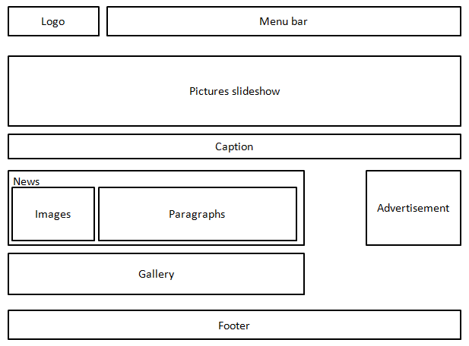

2)Top Highest, Top Longest, Top Oldest, World Famous pages:

3)Detail pages:

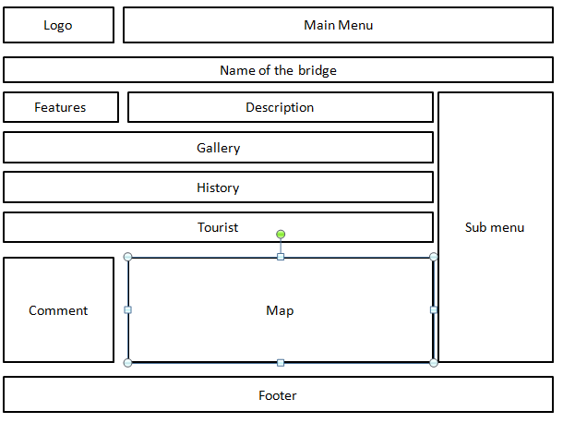

4)Contact page:

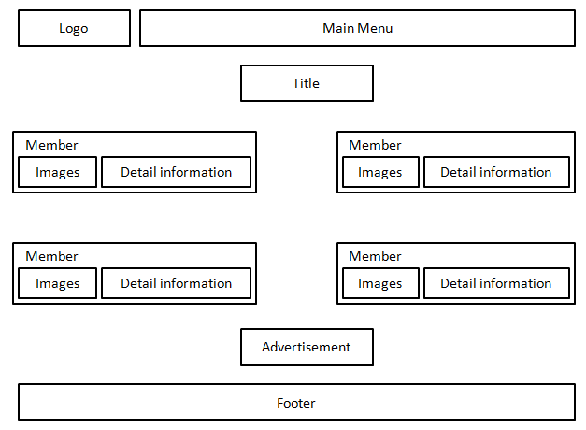

TASK SHEET REVIEW 2
No. | Description | Begin Date | TeamMate Name | Notes
1 | Mock of the website | 9/16/2017 | Minh
2 | Site map | 9/16/2017 | Chi
3 | Task sheet | 9/16/2017 | Minh

Date:
Signature of Instructor:  Le Mong Thuy | Signature of Team Leader:  Nguyen Huu Minh

Description:

- Homepage displays a few top famous bridges with short description about their features. Some advertisements will all so be shown on this page.
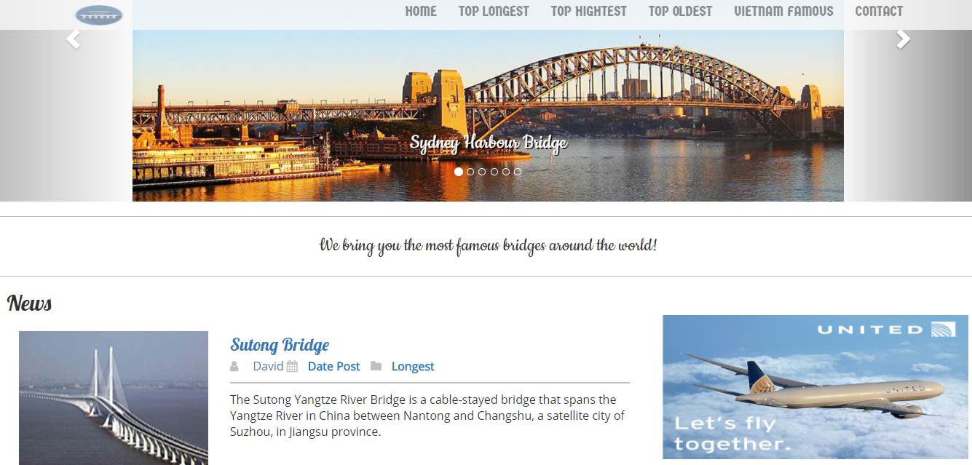
……………………………………………………………………………………………………………………………………………….
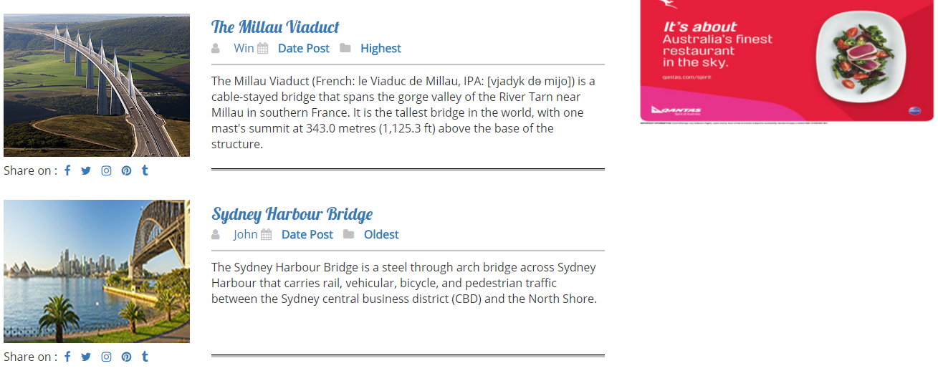
……………………………………………………………………………………………………………………………………………….
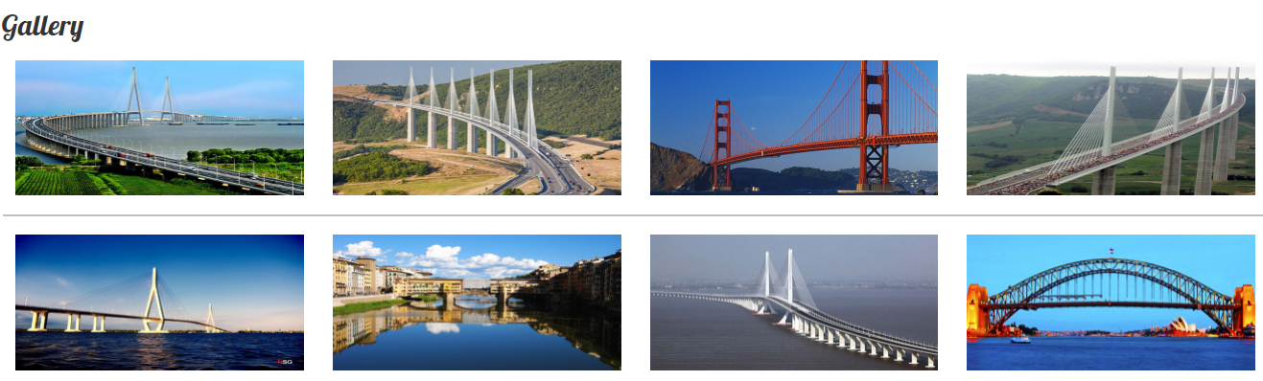

- Top Longest page presents short briefs of top longest bridgest around the world. If users want to have more information about a particular bridge, they can click on the image next to the description paragraph. It will then open up a detail page about that bridge.
- Top Highest page shows short briefs of top highest bridgest around the world. If users want to have more information about a particular bridge, they can click on the image next to the description paragraph. It will then open up a detail page about that bridge.
- Top Oldest page provides short briefs of top oldest bridgest around the world. If users want to have more information about a particular bridge, they can click on the image next to the description paragraph. It will then open up a detail page about that bridge.
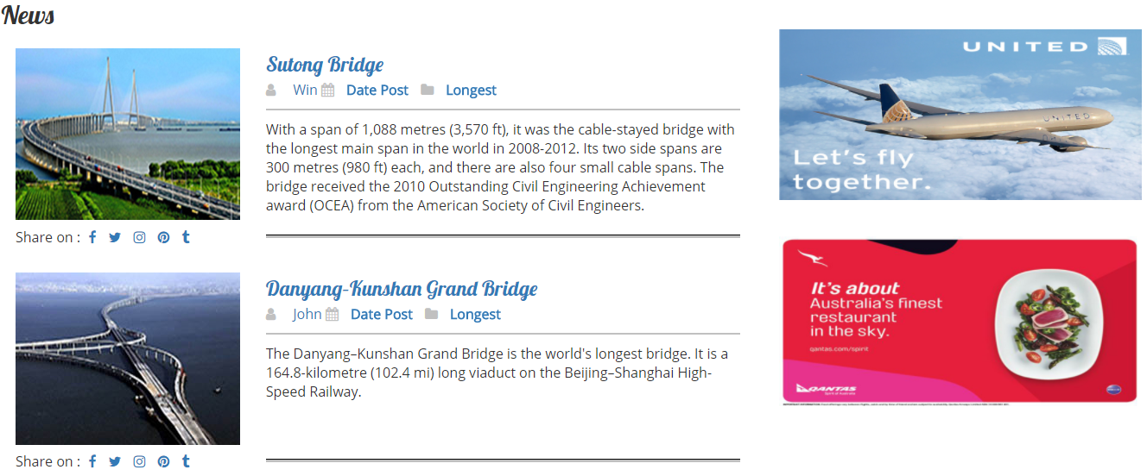
- World famous page includes short briefs of world famous bridges.
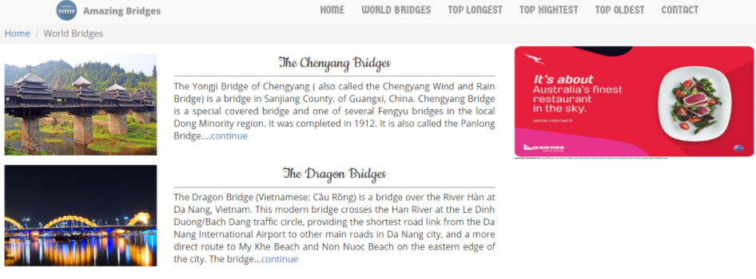
- Detail page displays full description of a specific bridge. More images of that bridge will be presented in the gallery. In addition, there is comment section which visitors can give feedback to AmazingBridges.com for improving purpose; they can also find usefull information which may help them get to the place.
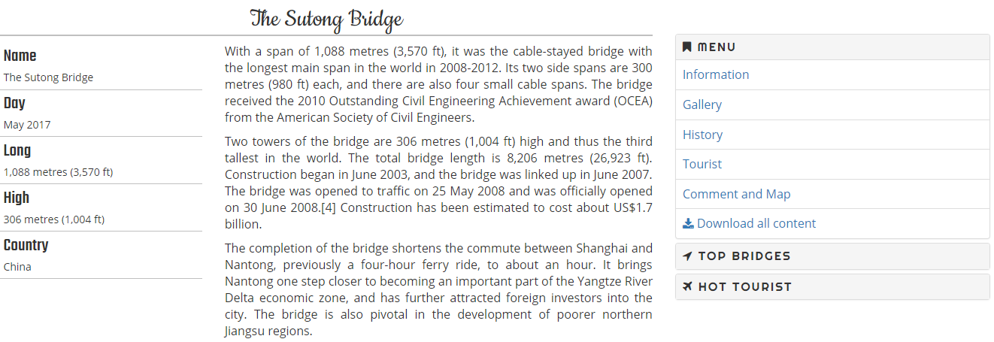
……………………………………………………………………………………………………………………………………………….
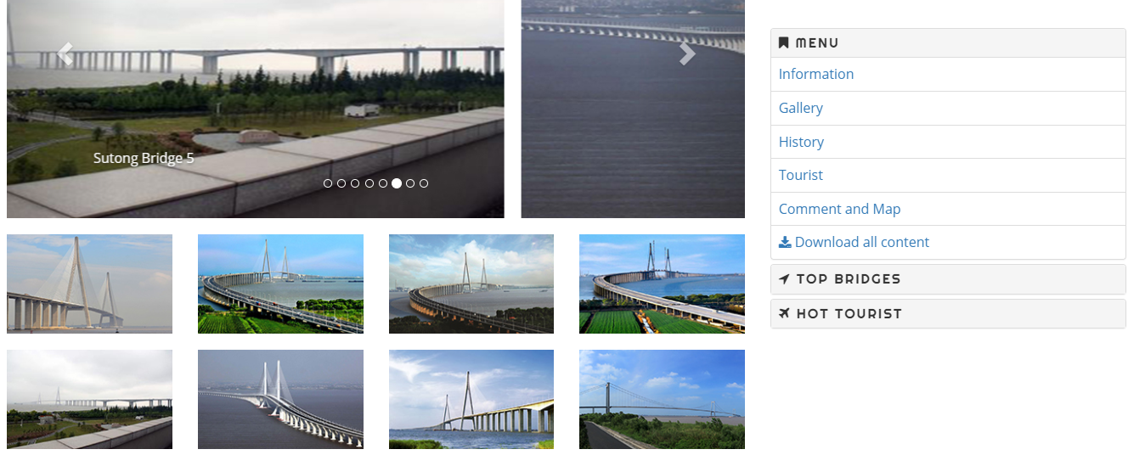
……………………………………………………………………………………………………………………………………………….
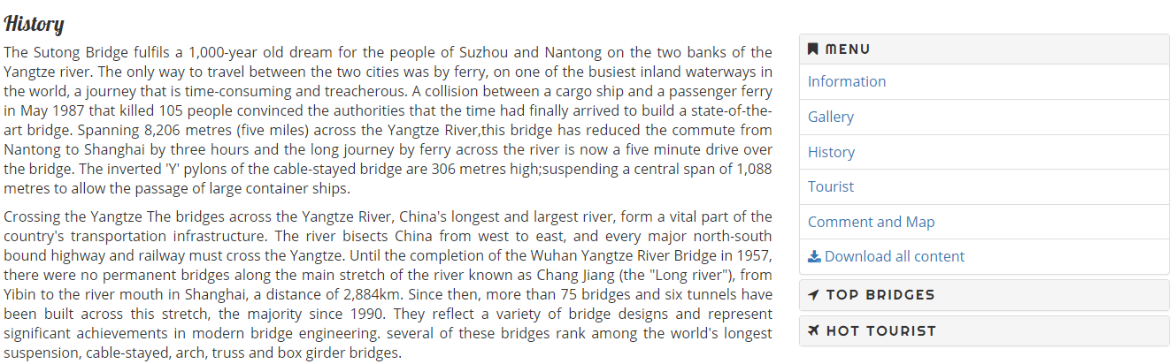
……………………………………………………………………………………………………………………………………………….

……………………………………………………………………………………………………………………………………………….
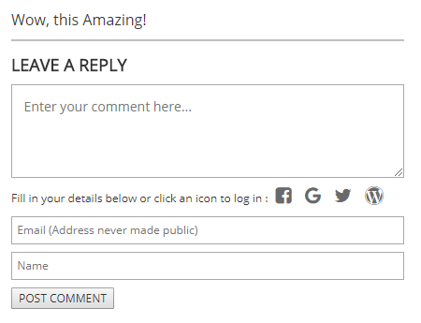
- FAQ gives visitors some helpful hints about what they are looking for by providing common sample answers.
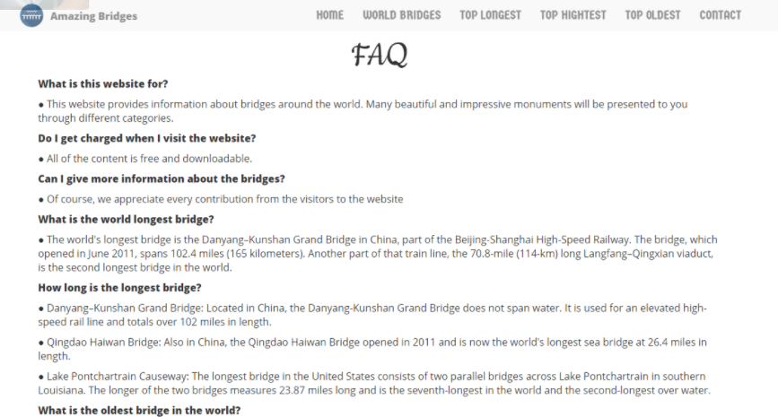

- Contact : Visitors can get in touch with AmazingBridges.com via email or phone number on the page.


TASK SHEET REVIEW 3

No | Page Name | Begin Date | TeamMate Name | Notes
01 | Homepage | 9/16/2017 | Minh
02 | Top Longest | 9/16/2017 | Ngoc
03 | Top Highest | 9/16/2017 | Ngoc
04 | Top Oldest | 9/16/2017 | Nhi
05 | Vietnam Famous | 9/16/2017 | Nhi
06 | Contact/about/FAQ | 9/16/2017 | Chi
07 | Detail pages | 9/16/2017 | Chi

Date:
Signature of Instructor:  Le Mong Thuy | Signature of Team Leader:  Nguyen Huu Minh

